**Android App Testing Screenshots**

Check-in

Row No.: 20

|  |  |  |  |  |
| --- | --- | --- | --- | --- |
| **Description** | **Test Steps** | **Expected Output** | **Status** | **Comments** |
| Verify navigation after confirming visitor details | 1. Navigate to review and confirmation screen 2. Click on the confirm button | User is navigated to the notification status screen followed by the visitor badge display within 2-3 seconds | Fail | When Confirm button is clicked and an email is sent to host, the visitor badge is not displayed |

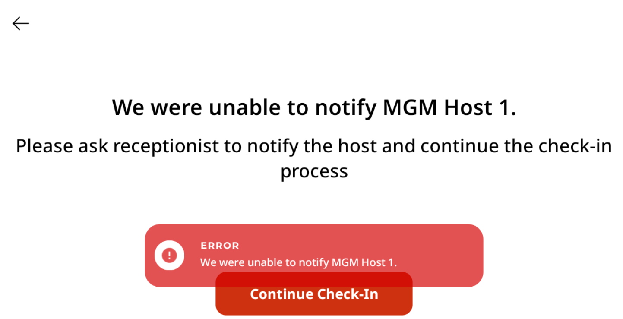

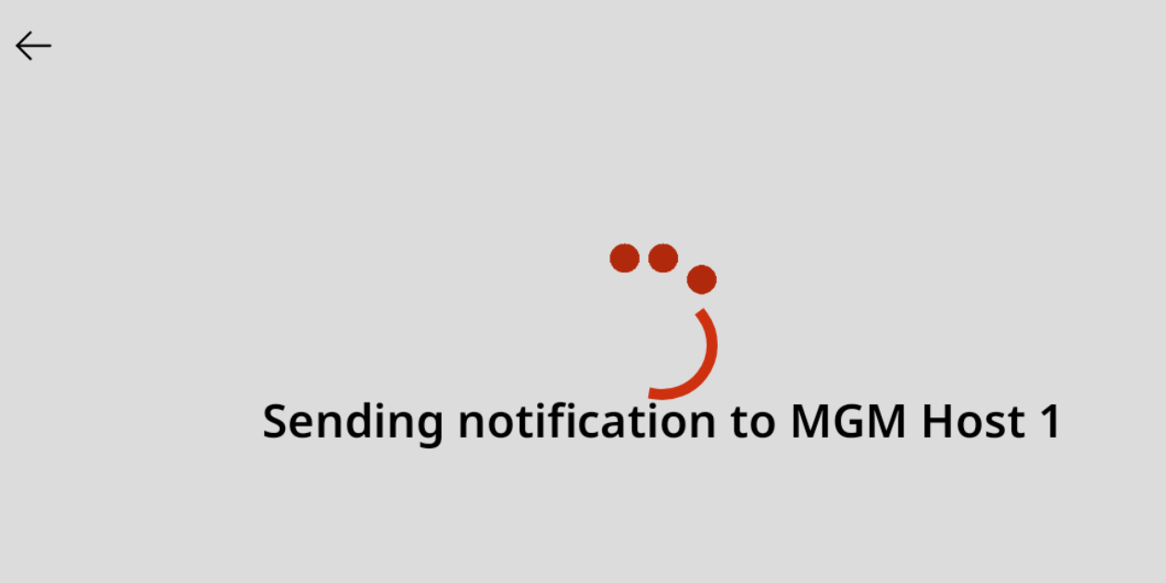

Row No.: 21

|  |  |  |  |  |
| --- | --- | --- | --- | --- |
| **Description** | **Test Steps** | **Expected Output** | **Status** | **Comments** |
| Verify visitor badge printing process | 1. Complete visitor check-in process 2. Reach the confirmation screen where badge is displayed | Visitor badge is printed by the printer | **Fail** | Vistor badge printing - not tested as confirmation screen where badge is displayed does not appear |





Row No.: 22

|  |  |  |  |  |
| --- | --- | --- | --- | --- |
| **Description** | **Test Steps** | **Expected Output** | **Status** | **Comments** |
| Verify host email notification | 1. Complete visitor check-in process with a valid host selection 2. Confirm visitor details | Selected host receives an email notification about the visitor check-in | **Fail** | Not able to check if the host receives an email notification |

Row No.: 27

|  |  |  |  |  |
| --- | --- | --- | --- | --- |
| **Description** | **Test Steps** | **Expected Output** | **Status** | **Comments** |
| Verify cancellation of check-in process | 1. Start the visitor check-in process 2. Click on cancel/back button at any stage | User should be navigated back to the home/landing page | **Fail** | User can only click the Back button and navigate to the previous page. It does not navigate to the landing page when back button is clicked. |

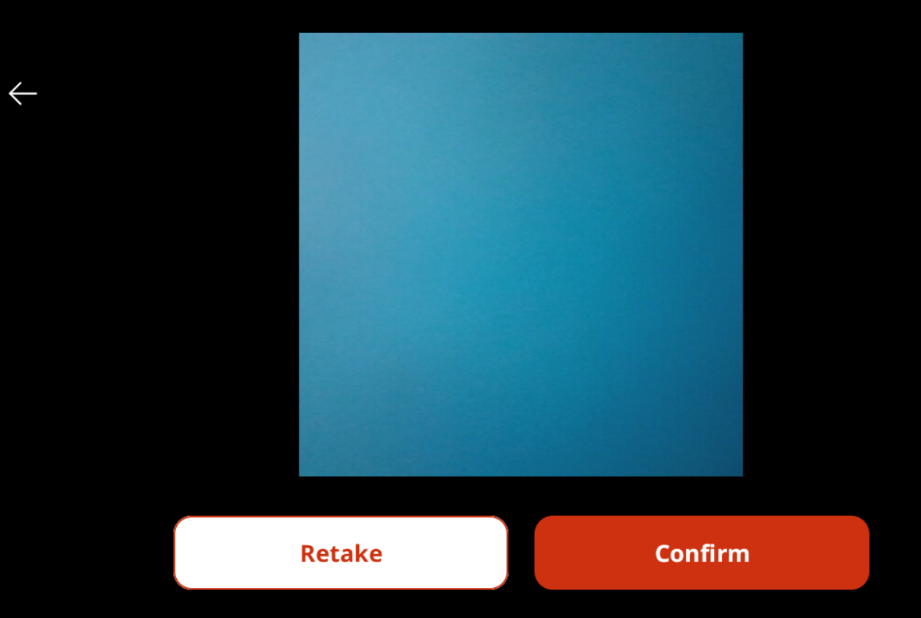

When back button is clicked, the following screen (camera capture) is displayed



Row No.: 33

|  |  |  |  |  |
| --- | --- | --- | --- | --- |
| **Description** | **Test Steps** | **Expected Output** | **Status** | **Comments** |
| Verify visitor badge includes all required information | 1. Complete visitor check-in process 2. View the generated visitor badge | Badge should display visitor name, host name, date, time, and any other required information | **Fail** | Visitor badge is not displayed |

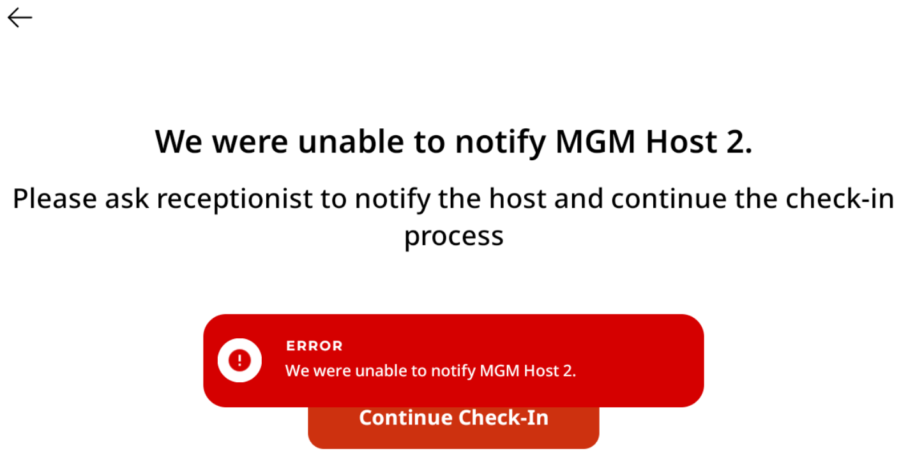

When Continue Check-In button is clicked, the following message gets displayed, instead of the visitor badge.

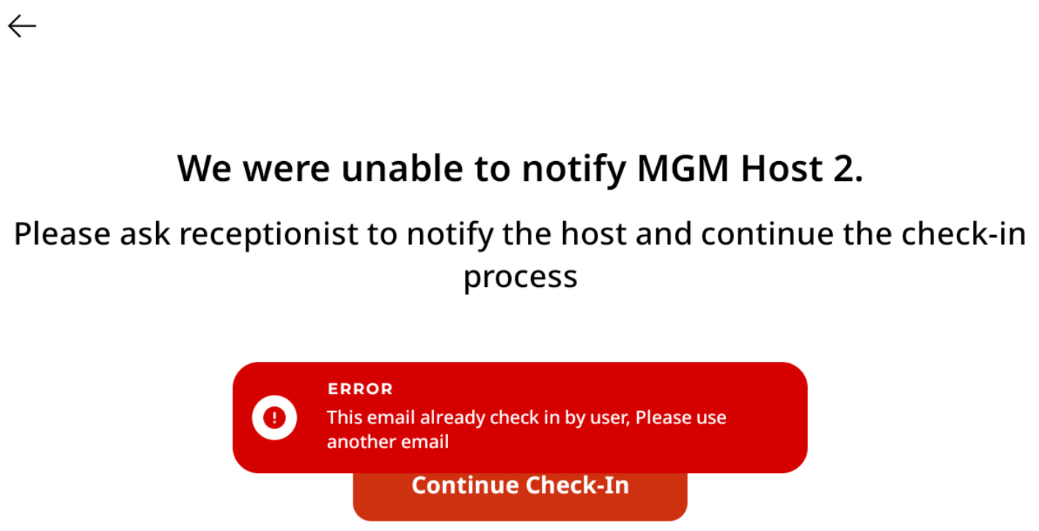

Row No.: 33

|  |  |  |  |  |
| --- | --- | --- | --- | --- |
| **Description** | **Test Steps** | **Expected Output** | **Status** | **Comments** |
| Verify visitor badge includes all required information | 1. Complete visitor check-in process 2. View the generated visitor badge | Badge should display visitor name, host name, date, time, and any other required information | **Fail** | Visitor badge is not displayed |



When Continue Check-In button is clicked, the following message gets displayed, instead of the visitor badge.

